

**APPENDIX A**

Draft Biodiversity Strategy

January 2022

# Document Control

|  |  |
| --- | --- |
| Publication Date | January 2022 |
| Related Documents | All related documents may be viewed via the SRBC website  [South Ribble Borough Council](https://www.southribble.gov.uk/) |
| Owner (Department) | Environmental Health |
| Author (Team) | Environmental Health / Climate Emergency Task Group |

**Review of Strategy**

|  |  |
| --- | --- |
| Review Date | July 2022 |
| Version | 1.0 |

Photo credits – Penwortham Conservation Volunteers and South Ribble Borough Council

Contents

Introduction 4

Strategy Objectives 4

National Context and Guidance 5

Planning Context 7

South Ribble’s Existing Strategies and Action Plans 8

Biodiversity Action Plans 8

Biodiversity in South Ribble 9

Invasive Non-Native Species 10

Habitats 12

Wetlands 12

Woodlands, Trees and Hedgerows. 16

Grasslands 19

Coastal Floodplain and Grazing Marsh 21

Arable Field Margins 22

Urban Green Space, Gardens, Allotments and Cemeteries 22

A Pollinator Pledge 23

Pesticide and Herbicide Use 23

Community Involvement 23

References 25

Glossary of Terms 26

# Introduction

The purpose of this Strategy is to deliver an overview of where we are at with regards to conservation in South Ribble and highlight ways to promote, conserve and enhance biodiversity across the Borough.

## What is Biodiversity?

Biodiversity is the term that describes the biological variety of our planet. It includes all plants and animals and the ecosystems that supports them and us – the food we eat, the water we drink and the air that we breathe. It happens all around us on a daily basis, often without us even noticing or valuing it.

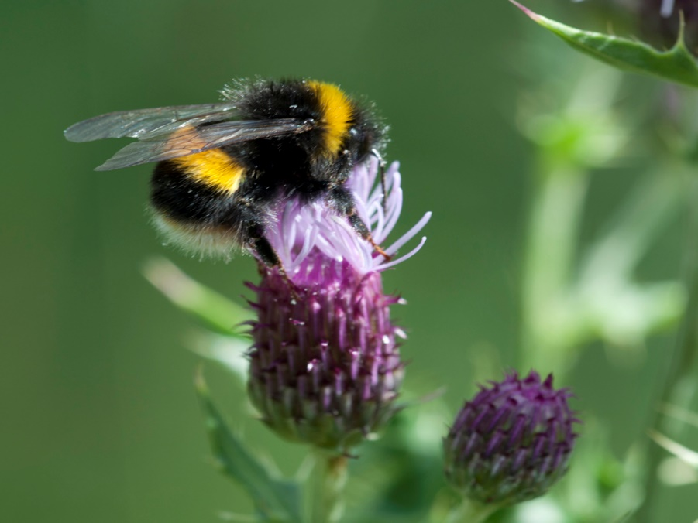

**White tailed bee**

At a local level biodiversity shapes the landscape of our area, our local distinctiveness and our economic prosperity. It contributes to good mental health and a sense of wellbeing. It has a role to play in our response to climate change, flood management, air, water and land quality.

Across the world biodiversity is under threat. The lives we currently lead compromises our biodiversity. Habitats are being lost or fragmented, isolating plant and animal communities into ever smaller areas. Pollution from intensive farming practices and industry result in higher levels of nitrogen’s and phosphates in our soils, air and water systems. Poor air quality globally leads to increased rates of nitrogen being deposited on our soils. Invasive non-native species are out competing the native flora and fauna, altering habitats, food chains and ecosystems. Climate change is affecting weather patterns and sea levels across the world, resulting in global affects that will be felt locally.

In the UK we have tamed our wild. The good news is that we can make a large difference in a generation and restore our natural ecosystems and reverse the effects of climate change.

The global response starts locally, and we all have a part to play, starting now.

# Strategy Objectives

This strategy is designed to sit with and complement existing strategies and action plans.

Strategy Vision – For a Borough where biodiversity is bigger, better and more joined up.

Networks of accessible, natural greenspace, linking areas of habitat that are positively managed for wildlife, biodiversity gain and resident enjoyment.

Strategy Aims: To ensure that South Ribble Borough Council’s responsibilities to conserve and enhance biodiversity is integrated into the work of all departments and there is a clear understanding of biodiversity and how it relates to decision making. That residents and businesses benefit from maintaining and improving a healthy green environment.

The main objectives of this strategy are -

* To act as a responsible landowner and land manager and conserve and enhance biodiversity.
* To highlight priority habitats and species that have value locally and nationally
* To highlight threats and issues that may adversely impact priority habitats and species
* To maintain, restore and create habitat connectivity
* To share good practice and develop partnerships
* To encourage education and community action / involvement
* To instigate a cross department ethos that will inform decisions
* To ensure development does not negatively impact on existing biodiversity across the Borough and where possible actively improves it.

# National Context and Guidance

Section 40 of the Natural Environment and Rural Communities (NERC) Act 2006, updated by the Environment Act 2021, places a legal responsibility on public authorities in England to have due regard for habitats and species of the greatest conservation importance, whilst protecting all biodiversity.

*“Every public body must, in exercising its functions, have regard, so far as is consistent with the proper exercise of those functions, to the purpose of conserving and enhancing biodiversity” s40 NERC Act 2006 (Updated)*

*“Conserving biodiversity includes, in relation to a living organism or type of habitat, restoring or enhancing a population or habitat” s40 NERC Act 2006*

The NERC Act requires all Local Authorities to be able to show that –

* Biodiversity and conservation are integrated throughout all policies and activities across the Council
* All staff, managers and Councillors understand how biodiversity issues relate to their decisions and actions
* All biodiversity, especially species and habitats of principal importance, are protected and enhanced
* It provides sustained support to local biodiversity initiatives
* It has access to up to date biodiversity information and professional ecological expertise
* It reports on progress towards and demonstrates progress against, national and local biodiversity targets

Section 40a of the Environment Act 2021 says Authorities must publish biodiversity reports which contain

* A summary of action which the authority has taken over the period of the report
* A summary of the Authorities plans for the 5 years following the report
* Quantitative data and any other information the authority considers is appropriate is include in the report.
* The first report must cover no longer than 3 years, subsequent reports must cover no longer than 5 years and run consecutively.
* The report must be published within 12 weeks of the last day of the report.

Section 41 of the NERC Act contains a published list of habitats and species which are of principal importance for the conservation of biodiversity in England and for which local authorities have a special responsibility to conserve.

“Principle Importance” defines those species and habitats that are the most threatened, in the steepest decline or where the UK has a significant proportion of the world total.

The Habitat Directives from the Conservation of Habitats and Species Regulations 2017 (as amended), aim to protect habitats and species of European importance. They make it a criminal offence to deliberately capture, injure, kill, disturb, trade or destroy the eggs or breeding site of any of the species listed and to pick, collect, cut, uproot, destroy or trade in any of the plants listed. This has been updated by the Conservation of Habitats and Species (Amendment) (EU Exit) Regulations 2019, whereby functions have been transferred from the European Commission to the appropriate authorities in England and Wales.

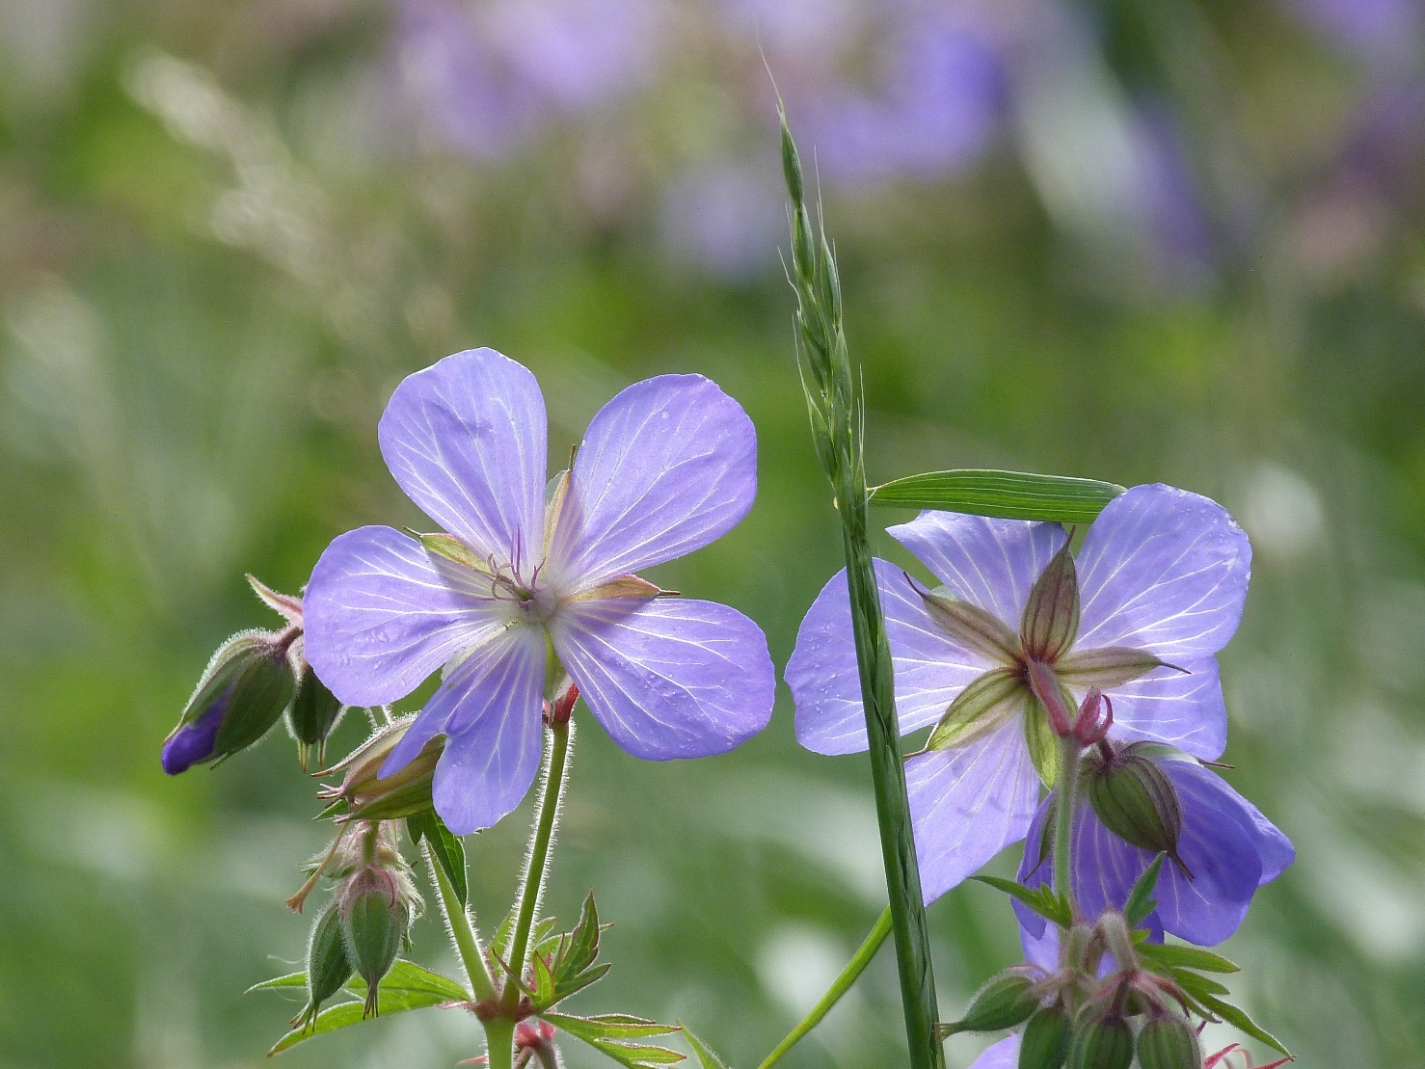

**Meadow Cranesbill**

The Environment Act 2021 will introduce new Local Nature Recovery Strategies (LNRS). Led by DEFRA and their nominated Responsible Authority, the LNRS will divide England into Strategy areas and will establish biodiversity priorities to drive nature’s recovery in each area and promote wider environmental benefits. As these are produced, they will be adopted and integrated in to this strategy.

# Planning Context

The area of biodiversity and climate change has grown quickly over the last few years as has the weight and value that is now placed upon these issues locally, nationally and internationally. The Environment Act of 2021 highlights this and means that this Act updates and supersedes many other Acts and subsequently the plans and policies that apply in South Ribble.

The current planning documents are –

* South Ribble Local Plan 2015

Sets out the vision for the borough and the Council’s interpretation of the Central Lancashire Core Strategy, including development management policies. It also allocates or protects land for different uses, such as housing, employment or play space. It is used for development management purposes to guide decisions on planning applications

* Central Lancashire Core Strategy 2012

The Core Strategy (Local Plan) was produced by the Central Lancashire authorities of Preston, South Ribble and Chorley, with assistance from Lancashire County Council. The purpose of the Core Strategy is to set the overall strategic direction for planning in the area over the period from 2010 to 2026, including where major development and other forms of investment should be located so as to be sustainable, meet local needs and take full advantage of opportunities.

* The Central Lancashire Biodiversity and Nature Conservation Supplementary Planning Document 2015

Supplementary Planning Documents (SPDs) provide further detail and guidance in relation to policies and proposals within the development plan. These SPDs form part of the Local Development Framework (LDF) for the Central Lancashire authorities of Chorley, Preston and South Ribble. They are to be considered alongside policy in the Central Lancashire Core Strategy and the Local Plans of the three authorities. The SPD guidance should be taken into consideration from the earliest stages of the development process of any site, including any purchase negotiations and in the preparation of development schemes.

* National Planning Policy Framework guidance notes.

The National Planning Policy Framework sets out the Government’s planning policies for England. It provides a framework within which locally prepared plans for housing and other development can be produced. The purpose of the planning system is to contribute to the achievement of sustainable development. It includes an environmental objective *to protect and enhance our natural, built and historic environment; including making effective use of land, improving biodiversity, using natural resources prudently, minimising waste and pollution, and mitigating and adapting to climate change, including moving to a low carbon economy*.

The document also identifies that authorities need to positively enhance the beneficial use of identified Green Belt areas to retain and enhance the landscape, visual amenity and biodiversity. Once defined as Green Belt, local planning authorities should plan positively to enhance their beneficial use, by looking for opportunities to provide access; to provide opportunities for outdoor sport and recreation; to retain and enhance landscapes, visual amenity and biodiversity; or to improve damaged and derelict land.

Individual planning decisions must ensure sites of principle importance are protected or enhanced and minimise the impacts on biodiversity. It states that if significant harm to biodiversity from a development cannot be avoided, mitigated or compensated for then planning permission should be refused.

**Biodiversity Net Gain (BNG) and the planning matrix**

The Environment Act 2021 requires that from 2023 all planning permissions larger than household permissions deliver a 10% net gain in biodiversity. A mitigation hierarchy will ensure that the most valuable land is saved and not offset. Where BNGs are not possible on the development site they can be compensated via local habitat creation.

Gains are to be guaranteed for 30 years.

BNG will work with an Authority’s Local Nature Recovery Strategy and any relevant species conservation strategy or protected site strategy prepared by the nominated Responsible Authority.

# South Ribble’s Existing Strategies and Action Plans

This Biodiversity Strategy is designed to sit with and complement existing Strategies and Action Plans

* Air Quality Strategy and Action Plan

Air quality can be improved by greening the environment as all plants capture and store CO2 and provide oxygen. Whilst trees are seen as important, they should not be planted at the expense of other habitats with equal or greater biodiversity importance.

* Climate Emergency Strategy and Action Plan

The offsetting targets of Climate Change Plans are often linked to the greening of the environment – tree planting, re-wildling, helping pollinators, championing peat free compost and rainwater harvesting. South Ribble aims to reach its targets without relying on offsetting.

* Tree Policy
* Flood Management Plans

Whilst these are County wide plans our resilience to flooding will be improved by greening the Borough and reducing hard landscaping. Sustainable Urban Drainage Schemes (SUDS) including the use of swales, soakaways and permeable paving will also reduce the likelihood and impact of flash flooding after major weather events.

# Biodiversity Action Plans

First produced in 1994 and last updated in 2007, the Biodiversity Action Plan identifies the habitats and species that are nationally important in the UK. These plans have now been absorbed into the Environment Act 2021.

Most of the threatened species can be protected by managing their habitats except in a few cases where targeted species management is required.

# Biodiversity in South Ribble

This section outlines the current understanding of the biodiversity across the borough

South Ribble Borough Council is a major landowner within the borough and manages an extensive network of green spaces. Effective management of our land relies on a good understanding of our biodiversity and our responsibilities and will encourage good management by other landowners.

There are several nationally and locally designated sites in the Borough

* Marine Conservation Zone

River Ribble Estuary up to Samlesbury

* RAMSAR – Wetlands of International Importance

River Ribble Estuary

* Sites of Special Scientific Interest (SSSI)

River Ribble Estuary

Beeston Brook Pasture (SD594278) Coupe Green area

Darwen River Section (SD613293) Samlesbury area

* National Nature Reserves

River Ribble Estuary

* Local Nature Reserves

Longton Brickcroft Nature Reserve in SRBC ownership

Preston Junction (LCC and Preston City Council ownership)

* Biological Heritage Site

A Lancashire County Council designation to protect locally important sites across the County. There are c.40 designated sites across the Borough.

Priority Habitats in South Ribble

* Rivers and Streams
* Ponds
* Hedgerows
* Woodland
  + Traditional Orchard
  + Wood Pasture and Parkland
* Lowland Meadows
* Coastal Floodplain and Grazing Marsh
* Arable Field Margins

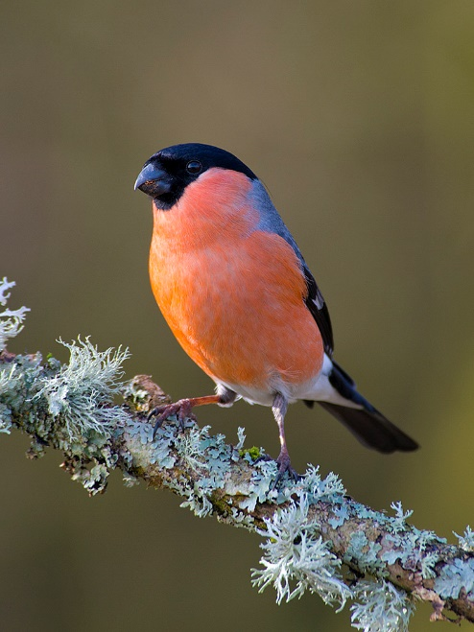Priority Species in South Ribble are shown in Table 1. This is a non-exhaustive list and is subject to seasonal changes. Species may need to be added and removed over time, the more iconic species at risk in South Ribble include –

**Bullfinch**

* Hedgehog
* Water Vole
* Bats (all species)
* Great Crested Newt
* Common Toad
* House Sparrow
* Common Starling
* Song Thrush
* Bees

# Invasive Non-Native Species

The introduction of new species to the UK, either deliberately or accidentally, has occurred for thousands of years. Many of the species have escaped from private collections and have spread rapidly at the expense of our native species, for example the grey squirrel. These are termed Invasive Non-Native Species, or INNS. Invasive non-native species have an impact on biodiversity by out competing native species because they dominate or destroy habitats, or by introducing new diseases or parasites. These can be plant, animal or insect species.

# Partnership Working

Biodiversity does not respect political or other boundaries. Therefore, we will need to work closely with neighbouring Boroughs and other landowners within and without South Ribble to have a wholistic, zoomed out approach to conserving our biodiversity.

Biodiversity is an integral part on the Council’s response to the Climate Emergency and as such will form part of the engagement work that is being undertaken in this area.

Table 1 – Priority Species known to be in South Ribble

# Habitats

## Wetlands

### Rivers and streams

Priority Habitat description - *The majority of rivers across the UK are expected to fall into this category when they are in a ‘near-natural’ state, canals and ditches are not included. The aim is to keep the naturalness of a river and increase it, where possible, in other parts of the river system. The river is classified to the top of the banks, surrounding land may form priority habitat in its own right and be integral to the river system and its management but is classified in its own area. Adjacent ponds will only be included if they were naturally formed by the river (Oxbow lakes) but not if formed artificially or by other processes. Aquatic, marginal and bankside plant and animal assemblages are an integral part of the river habitat.*

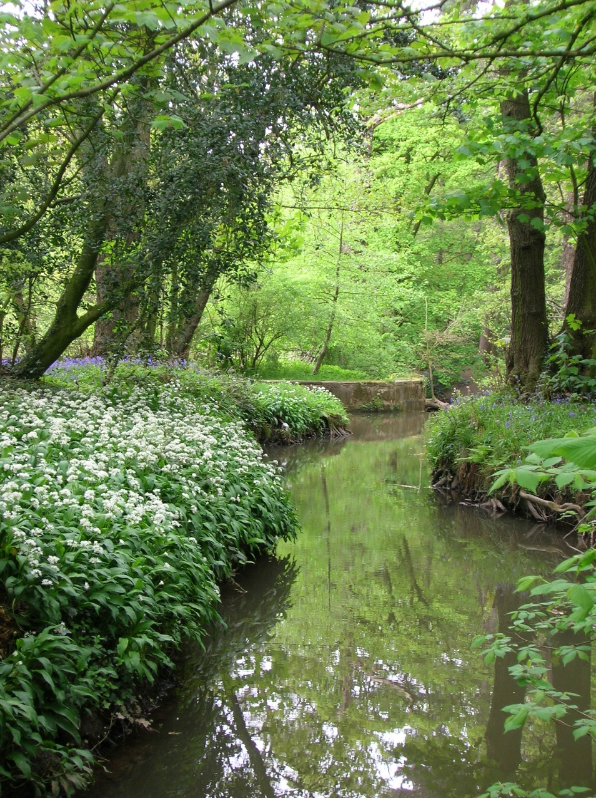

Shaw Brook, Worden Park

Across South Ribble the Council is responsible for the riparian management of sections of the River Ribble, which acts as the northern boundary of the Borough, the River Lostock (Lostock Hall and Leyland), Shaw Brook (through Worden Park and Wade Hall, Leyland) and Bannister Brook (visible at various points through Leyland). The rivers Yarrow and Douglas also flow through the Borough.

The Environment Agency have the statutory responsibility to carry out maintenance, improvement or construction work on all main rivers to manage the flood risk. In South Ribble these are The Ribble, Lostock, Yarrow, Douglas and their main tributaries and Shaw Brook as a tributary of the Lostock. Other watercourses are maintained by the local flood authority, district council and landowners.

Rivers act as important wildlife corridors allowing species to move across the Borough, attracting aquatic and terrestrial wildlife. Rivers naturally twist and turn with areas of deposition and erosion along their length. This is an important natural process and should not be subject to human intervention without careful considerations of the knock-on effects of flooding and habitat loss up and downstream from the work. Watercourses should be kept free of obstructions that may cause flooding and trap litter and pollutants and therefore be a hazard to wildlife.

Most human intervention in our rivers is to control bank erosion and mitigate flood risks. Shaw Brook in Worden Park was altered historically by the Farington family when the land was part of their estate. Any future work here should consider the historical as well as the biodiversity and flooding implications.

Rivers attract people for recreation and the banks should be seen as part of the river habitat. Damage caused by humans to the riverbanks directly impacts on the quality of the watercourse.

The Environment Agency undertake water quality checks, but improvements are also evidenced by increased wildlife sightings. It is not uncommon to see otters in local rivers across South Ribble, a direct response to improving water quality and food availability.

The main threats to our river systems are –

* Pollution
* Development on riverbanks and floodplains
* Culverting (diverting the main channel into a pipe or culvert to change the flow)
* Riverside footpaths and recreational access - causing disturbance to habitats and species
* Invasive Non-Native Species

### Ponds

Priority Habitat description - *permanent and seasonal bodies of water up to 2 hectares in size and of landscape importance and/or high ecological value – supporting ecologically important plants, aquatic invertebrate or amphibian species*.

There is a mosaic of ponds across South Ribble. Many are natural and show up on the historic maps of the Borough, others are man-made, constructed as part of housing developments or conservation projects. All have an important part to play in the biodiversity of the Borough.

Ponds support a large range of wildlife from insects and amphibians to birds and aquatic plants. Some species are wholly dependent on ponds for all or part of their lifecycles. Natural ponds are best for wildlife, but sympathetically created ones are valuable particularly in urban areas. Ponds can vary from 1m2 to 2 hectares in size. Clusters of ponds are more valuable than one large one especially if they are different sizes and at different stages of a lifecycle.

The area around the pond, known as the margins, is equally important as it provides shelter and hibernation sites for aquatic and terrestrial wildlife. For this reason, best practice states that a minimum 3-meter-wide strip around each pond is left unmanaged as a buffer zone.

Whilst there is a long tradition of feeding the ducks in the UK, large wildfowl numbers and excess amounts of bread and seed left in and around the ponds is detrimental to the pond and its wildlife. Excess food attracts rats, classed as an INNS, who’s populations explode, which in turn displaces populations of small mammals, causes bankside erosion, spreads disease and upsets the pond ecosystem. This can be controlled by only feeding the ducks in designated areas and allowing Wildlife Ponds to stay wild.

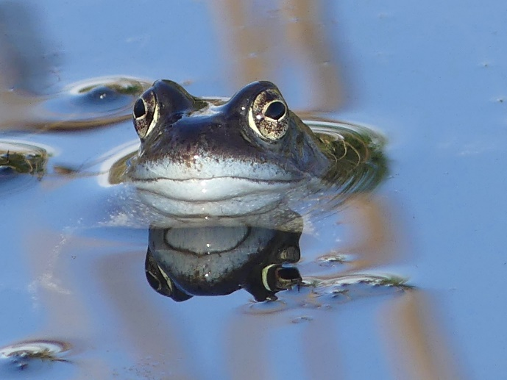

**Frog**

Pond dipping is a popular educational activity with schools and uniformed groups. Numbers of groups dipping should be regulated so that it does not cause a detrimental effect to the pond and its wildlife and margins.

There are breeding populations of Great Crested Newts in several ponds across South Ribble. These creatures are a European protected species. The animals and their eggs, breeding sites and resting places are protected in the UK under the Wildlife and Countryside Act, 1981, as a Priority Species under the UK Post-2010 Biodiversity Framework and listed as a European Protected Species under Annex IV of the European Habitats Directive.

In order to carry out conservation and educational activities on these ponds a small number of Council Officers have a Great Crested Newt license issued annually by Natural England. A prerequisite of this license is that ponds containing or suspected to contain Great Crested Newts are surveyed annually and the results reported to Natural England and the local records office.

Management of ponds is important to control the growth of aquatic and marginal vegetation to retain areas of open water that allow light to enter the pond and wind movement across the pond. Open areas also allow displaying and breeding areas for newts and amphibians. Trees should not be planted to the south of the pond as this block’s sunlight. Management works should take place autumn / winter (November to January) – when the amphibian breeding season has ended and before species start to hibernate and cannot be disturbed. Work to ponds outside this timeframe will need to have a license from Natural England.

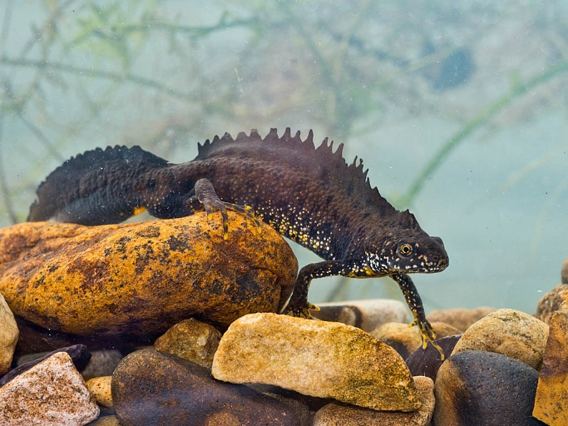

**Great Crested Newt**

Biological materials (plants and animals e.g. frogspawn) should not be transferred between ponds to reduce the risk of transferring invasive species and disease.

There are a number of larger ponds in South Ribble that are designated as fishing ponds and managed under a formal lease agreement by independent Angling Clubs. Fishing is only permitted on these designated waters and is controlled by the Angling Club and their bailiffs. South Ribble Borough Council retains the right to terminate leases and remove the fish stock from a designated pond if circumstances deem this the best course of action. Fish should not be introduced to any other ponds as they have a severe impact on many aquatic plants and animal species.

The main threats to our ponds are –

* Pollution,
* Eutrophication (Nutrient enrichment from run off)
* Infilling
* Algae blooms
* Invasive pond weeds and plants
* Litter and over feeding of wildfowl
* Fish
* Poor management – removal of all aquatic vegetation and removal or marginal vegetation and mowing pond edges – loss of biodiversity.

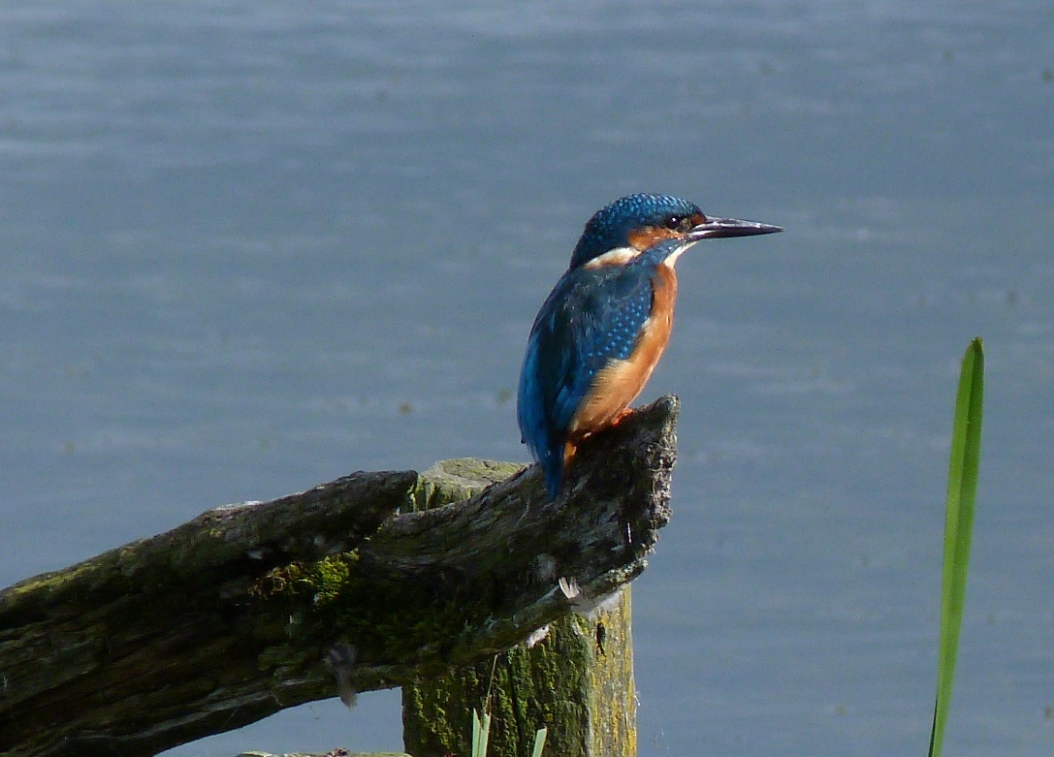

**Kingfisher**

### Bog Gardens

Bog gardens are an excellent habitat created as a stand-alone habitat in a waterlogged area or as an extension to a pond margin or as an alternative use to a failed pond. It is a permanently damp area where moisture loving plants can thrive. As these plant species are different to those found in a pond it will attract different wildlife.

It is a safer alternative to a pond in areas where these would not be safe – school grounds for example, but it will still attract frogs and toads, bees, butterflies and damsel and dragonflies.

Due to the seasonal nature of plant growth in these areas, they do not always look at their best and often look wild and unmanaged. This needs to be seen as a positive for wildlife and not a failing on maintenance teams. Wild areas are great for wildlife.

### Invasive Non-Native Species Management

River catchments and ponds are particularly vulnerable to invasive species.

Along riverbanks, dense stands of Himalayan balsam (*Impatiens gandulifera*), Giant hogweed (*Heracleum mantegazzianum*) and Japanese knotweed (*Fallopia japonica*) risk out competing and crowding out native species, changing the ecosystem. This threatens the appearance of the landscape, can prevent access to riverbanks and may impede the flow of water, therefore exacerbating flood risk. When these invasive species die down in winter, they may leave the riverbanks bare, exposing them to increased soil erosion. Japanese knotweed and Giant Hogweed are notifiable species that need professional management to control and reduce their growth.

In ponds INNS include - Water fern (*Azolla filiculoides)* New Zealand pigmyweed (*Crassula helmsii)*, Floating pennywort (*Hydrocotyle ranunculoides)*, Curly waterweed (*Lagarosiphon major)*, Least duckweed (*Lemna minuta)*, Parrot's feather (*Myriophyllum aquaticum)* and Broadleaf watermilfoil (*Myriophyllum heterophyllum).* American skunk-cabbage *(Lysichiton americanus)* is present on the banks of the Chain Pond at Worden Park.

Animal and bird species can also be classed as INNS such as the Canada goose (*Branta canadensis)* which breeds prolifically on some of the ponds in South Ribble and the American mink *(Mustela vison*) which predates upon and outcompetes water voles and otters.

Some, if not all, of these species are present in ponds in South Ribble, introduced from garden ponds in to the wild and now spreading throughout our pond and river systems.

### 

### Biosecurity

Whenever work is being undertaken in or near any watercourse or pond, stringent biosecurity practices should be adhered too. This includes cleaning and disinfecting tools, footwear and clothing between ponds to stop the spread of invasive species and disease.

## Woodlands, Trees and Hedgerows.

South Ribble is a Borough rich in trees and hedgerows which are an important visual, wildlife and recreational resource. Many of these are on Council owned land and their management is covered by the South Ribble Borough Council Tree Policy. This section does not override anything written in this policy which states in summary that - *trees will only be removed when it is in accordance with good arboricultural practice, or as part of a management plan for the area and will look to increase its tree stock whenever possible by replanting on a two for one basis (two trees planted for every one felled).*

### Woodlands and Individual Trees

Woodlands and their associated ground flora are valuable as they support invertebrates, birds and mammals. Deadwood is vital for invertebrates, fungi, ferns and lichens.

The Big Tree Plant project aims to plant 110,000 trees across the Borough before 2022, one for every resident of the Borough. It aims to improve air quality and contribute to the Council’s commitment to be carbon neutral by 2030. The Council does not own enough land to make this possible, so residents, schools and landowners are all being invited to pledge space for trees.

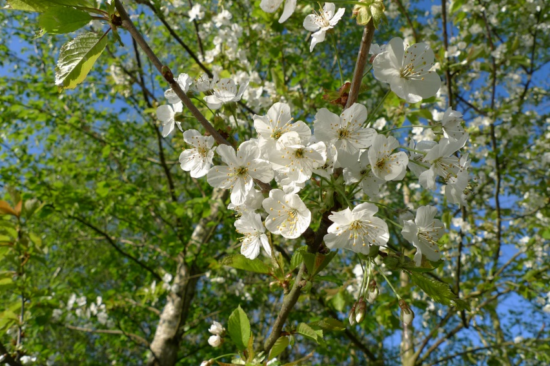

Cherry blossom

Fundamental principles have been followed as part of this planting project and should be considered for all tree planting going forward beyond this scheme including,

* Where new planting is to be undertaken it should be of locally occurring native species only, unless in a formal more ornamental setting such as the arboretum on Worden Park.
* New woodlands are not planted at the expense of other important habitats and care is taken to choose sites that add to the diversity of the Borough rather than detracting from it.
* Where feasible new planting shall link together existing woodland, creating corridors that allow the natural spread of plants and animals.

Individual trees and small copses also have worth for their conservation and amenity value and should be protected from mismanagement and loss.

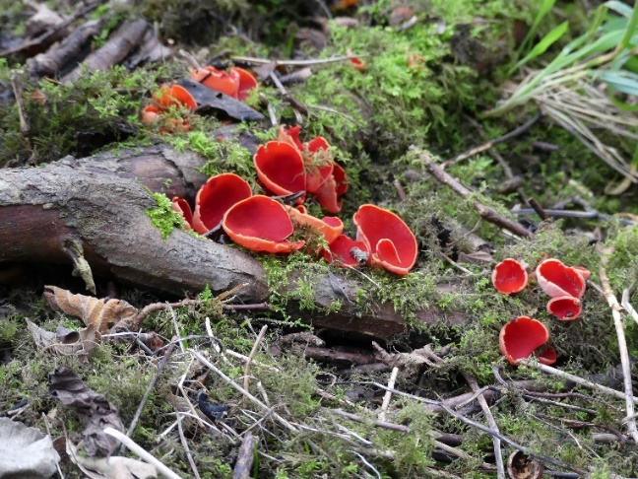

Scarlet elf cup

Management is vital in sustaining a healthy woodland in a favourable condition for recreation and wildlife. A healthy woodland has a diverse age structure in its tree population with mature established trees and new natural regeneration. Invasive non-native species and dominant ground cover, such as bramble, should be controlled to allow the growth of ground flora and new self-seeding trees. With light reaching the woodland floor, flower species like bluebell and wood anemone, will thrive.

Deadwood plays a key role in woodland ecosystems, as it supports specialist saproxylic species that depend on decaying wood, such as invertebrates, mammals and cavity nesting birds. It has particular value along woodland edges when it is mixed with shrubby trees and taller plants and wildflowers.

Standing deadwood differs from fallen deadwood as it is warmer, and rots slower providing another habitat and should be retained in situ wherever possible.

### Wood Pasture and Parkland

The parkland landscapes of Worden and Hurst Grange Parks are a priority habitat (Wood Pasture and Parkland). Here *native ancient and veteran trees dominate an open designed landscape dating from the 19th century or later*. The Cedar of Lebanon in the formal gardens at Worden Park also falls into this category *as nationally they are rare and under threat*. The sweet chestnut at the rear of the formal gardens on Worden Park is also notable as the oldest tree on the Park.

### Traditional Orchards

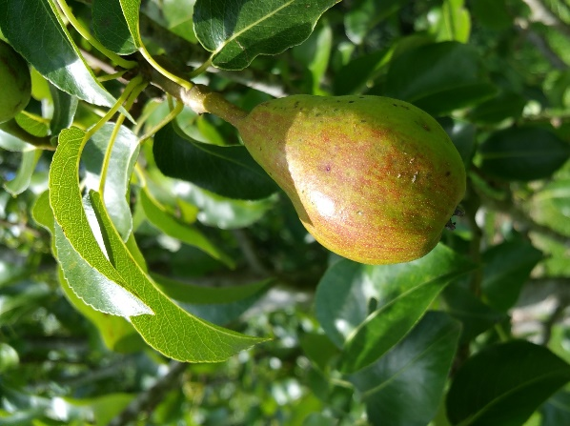

**Pear**

Priority habitat description - *predominated by domestic fruit and nut species (apple, plum, pear, damson, cherry, walnut and hazel) planted in permanent grassland and managed in a low intensity way, without pesticides and fertilizers and frequent mowing (hay crop or grazing). Trees spaced 3m plus apart. Young trees and newly planted orchards are included in this definition. A minimum of 5 trees with crown edges less than 20m apart.*

Remnants of an old orchard are visible at Paradise Park, Leyland. New orchards have been planted at Worden Park and Paradise Park. Several schools have also planted small orchards as part of the 110,000-tree project.

### Hedgerows

Priority habitat description - *any boundary line of trees or shrubs over 20m long and less than 5m wide. It includes all banks, walls, ditches or trees within 2m of the center of the hedge plus herbaceous vegetation within 2m of the hedge*

Hedgerows are excellent wildlife corridors allowing mammals, birds and invertebrates to live in and move around our Borough. Vegetation at the hedge bottom allows extra cover for wildlife and increases the species present around the hedge increasing its biological value.

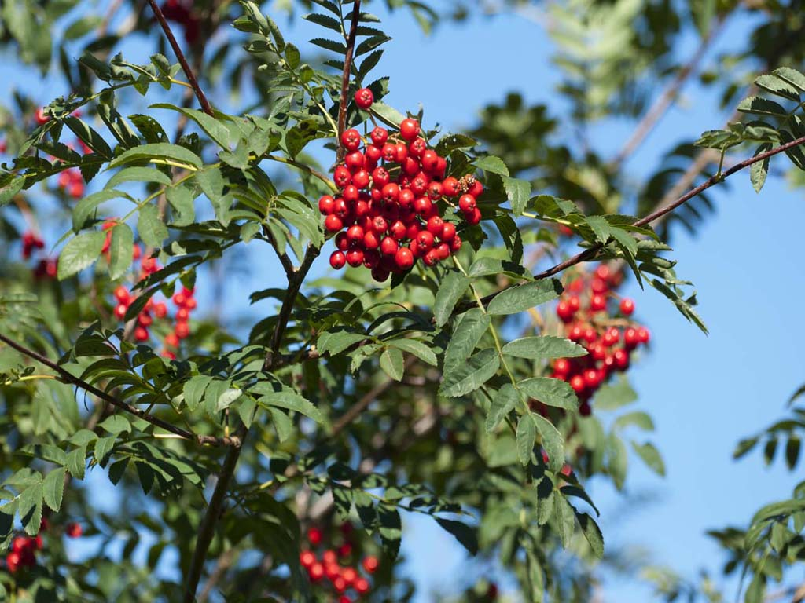

Rowanberries

Large ancient hedgerows made of native trees and shrubs are the most valuable for wildlife, due to the diversity of species present. Newly planted hedges can be valuable too if they are species rich. Gapping up hedgerows, by planting up the spaces left as trees die, is very valuable as it links up existing and provides new habitat.

Hedgerows are protected under the Hedgerow Regulations Act 1997 and permission for removal is required prior to any work.

Hedgerow management is important in maintaining a hedge. The tradition management method is to lay the hedge (cutting partway through the trunk at the base and leaning it over at a 45-degree angle), and this is still practiced across the Borough. Cutting and flailing are also practiced but mean that new growth comes from the top of the hedge rather than the base. All methods reduce cover in the short term and eliminates some of the flora, so should be planned carefully. With all methods timing is crucial and it should be carried out while the hedge is dormant. Work on hedgerows during the bird breeding season should only be carried out if the hedge is causing an obstruction to access or traffic sight line issues.

### Invasive Non-Native Species Management

In woodlands INNS include - Rhododendron (*Rhododendron ponticum),* Non-native bluebells, the Spainsh bluebells and all hybrids with our native bluebell *(Hyacinthoides non-scripta x hispanica = H. x massartiana),* Yellow archangel *(Lamiastrum galeobdolon subsp. Argentatum)*, Turkey Oak (*Quercus cerris),* Evergreen oak (*Quercus ilex*), Cherry laurel *(Prunus laurocerasus),* European rabbit *(Oryctolagus cuniculus)* and Eastern grey squirrel *(Sciurus carolinensis).*

Ash dieback (Hymenoscyphus fraxineus) is a fungus that originated in Asia and was introduced to Europe around 30 years ago. It has decimated populations of European ash (Fraxinus excelsior) as there they have no natural defence against it. It is expected that Ash dieback will kill around 80% of ash trees. This has already started in South Ribble threatening the look of our landscape and the species that depend on our ash trees. It is being monitored and trees removed as they become unsafe. There is no know way of stopping the spread of the fungus. It is hoped that given time (50 years plus) our ash trees will start to develop resistance to the disease.

The main threats to our woodlands, trees and hedgerows are

* Ash dieback
* INNS
* Poor management
* Removal of all deadwood
* Dominant species left to grow unchecked
* Spraying of hedge bases

## Grasslands

### Lowland Meadows and Road verges

Priority habitat description - *road side verges, unimproved neutral grassland taken as a hay crop and including inundated grasslands, water meadows and wet meadows. These are often localised, fragmented and small in size.*

Hurst Grange Park, Penwortham, is the largest expanse of unimproved neutral grassland in the Borough and is designated as a Biological Heritage Site by Lancashire County Council. It supports good populations of Southern marsh orchid (*Dactylorhiza praetermissa)* and Common spotted orchid (*Dactylorhiza fuschii)* and their hybrids. Other areas managed as hay meadows with an annual cut and collect by a contractor are Worden Park, Paradise Park, Priory Park and Priory Meadow.

Roadside verges are often overlooked for their wildlife value, but well managed verges create vital links across the borough as well as being a biodiversity resource in their own right. In South Ribble most roadside verges are cut on contract for Lancashire County Council and any changes will have to be agreed with them as landowner.

All areas of naturally occurring wildflower meadows and wild roadside verges are vulnerable to changes in management, development, neglect and disturbance. They provide an ideal habitat for small mammals and the prey species that predate on them.

Opportunities to create new perennial natural meadows are limited as they require poor quality soils or brownfield sites. It is almost impossible to establish a successful meadow on good quality soils as richer soils lead to vigorous grass growth which outcompetes wildflowers.

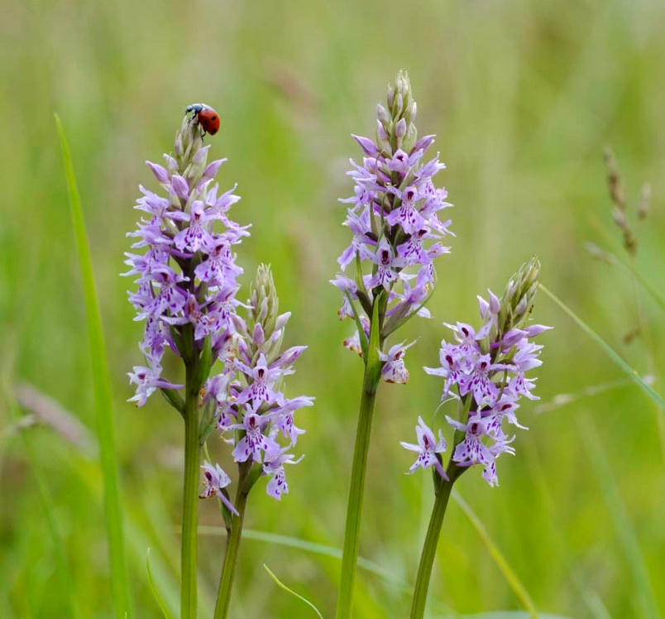

**Ladybird on orchids**

Lack of, or poor management can mean that a species rich meadow soon becomes a rank grassland, dominated by grasses and other competitive species like dock and thistle. Pesticides and herbicides reduce plant diversity and therefore numbers of pollinating insects. Meadows require a well-planned mowing regime to ensure that seeds, stems, and nectar are available to wildlife throughout the year. Cutting should take place after the wildflowers have set seed and arisings removed after a few days, allowing the seed to drop, but limiting the release of nutrients into the soil. Cutting too early will remove resources for pollinators across the summer months. Parcels of rank, tussocky grass left over winter will provide refuge for overwintering invertebrates and areas should be rotated annually to avoid a buildup of thatch and an increase in nutrient levels. Any seed heads left will feed seed eating birds like goldfinch and linnet.

Sympathetic repair of any damage to the meadows can to be undertaken with an appropriate seed mix apart from where the meadows contain populations of orchids. Seed mixes should include yellow rattle *(Rhinanthus minor*) which out competes some of the grasses allowing wildflowers to establish more easily. Orchids have a symbiotic relationship with a fungus in the soil and cannot grow if the fungus is not present. This means that they cannot be transplanted and suffer if new soil is brought in.

### Urban Flower Meadows

These are the meadows that are created each spring on areas of land owned by South Ribble. They use annual non-native seed mixes and are labour and cost intensive as the area has to be cut, sprayed, rotovated, sown with seed and then cut down at the end of the season. They do however look very nice and provide a short-term source of nectar for our pollinators. They should not be created in areas where there is any chance of the seeds spreading into wild areas of the Borough.

### Amenity grassland

This refers to all areas of mown grass such as sports pitches and parks. It is of some use for foraging birds, such as starlings and blackbirds looking for worms, but its main use is for

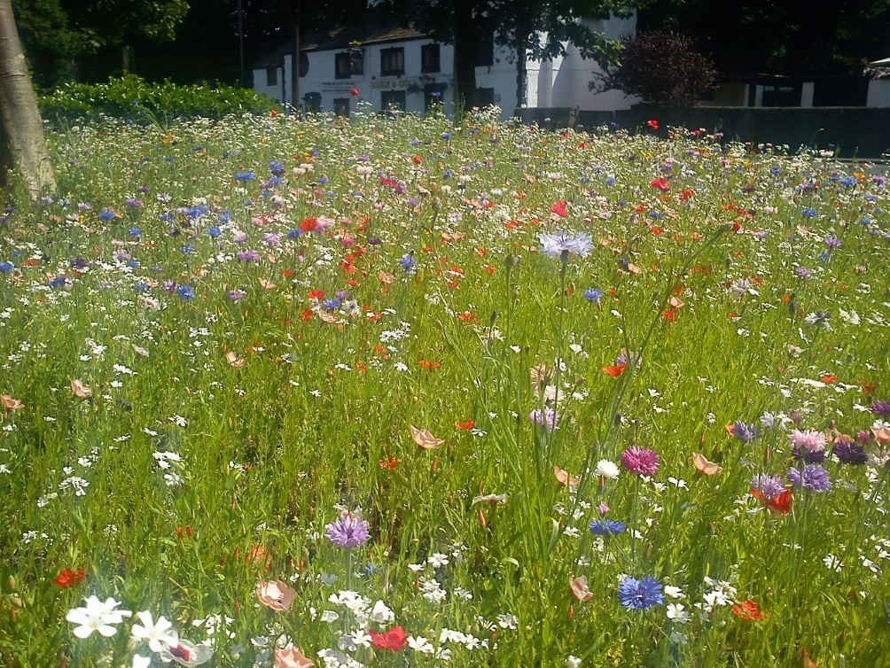

Urban meadow

recreation. If mown in a way where species such as daisy, clover and dandelion are allowed to flower, it can be useful for pollinators.

Adjusting our maintenance regimes to include different sward heights by differential mowing around the boundaries, would increase biodiversity and allow us an opportunity to increase the natural value of our urban areas.

The threats to our grasslands are

* Mismanagement
* Development
* Tree planting
* Disturbance
* Difficulties in creating new natural meadows
* Pesticide use
* Seed from non-native (urban meadows) spreading in to the wild

**Invasive Non-Native Species Management**

Whilst there are currently no INNS occurring in South Ribble’s grasslands it should still be monitored. INNS such as Himalayan balsam and Japanese knotweed can easily encroach or be introduced from other areas.

## Coastal Floodplain and Grazing Marsh

Priority habitat description - *periodically inundated pasture or meadow with ditches containing standing brackish or fresh water. Grazed or hay or silage crops.*

This is limited to the Ribble Estuary and is not under the ownership or management of South Ribble Borough Council but still forms an important habitat within our Borough.

## Arable Field Margins

Priority habitat description - *herbaceous strips or blocks around arable fields that are managed specifically to provide benefits for wildlife.*

Large areas of the Borough are used for farming and this landscape is characteristic of the eastern and western parishes. Whilst under private ownership and management these fields and their margins provide an important habitat within our Borough.

## Urban Green Space, Gardens, Allotments and Cemeteries

**Robin**

These urban areas can be a haven for wildlife, creating a mosaic of different habitats that link urban areas to the countryside.

Formal planting in town centers and on Worden Park is aesthetically pleasing and provides a short-term source of nectar for many insects which in turn provide food for birds and bats.

Residents’ gardens and allotments are an important part of South Ribble’s biodiversity. They provide important food sources of nectar and berries supporting our wildlife throughout the year. Garden ponds, trees, hedges, compost heaps and flower beds all support a diverse range of species and are often essential for their survival. Biodiversity gains are best where gardens adjoin each other, where mature trees are retained, and ponds created. These gardens create a network of green corridors and patches which helps to facilitate the movement of species between areas.

Leaving space for nature in a garden means cutting hedges outside of bird breeding season, having wildlife ponds rather than fishponds, leaving wild areas with piles of leaves and sticks/logs and building a compost heap. Avoiding the use of pesticides and slug pellets wherever possible will also help wildlife. Compost heaps provide nesting sites for hedgehog and grass snake, garden ponds are refuges and breeding areas for frogs, toads and newts, and flowering plants and shrubs are a food source for bees and butterflies and other insects.

The threats to our urban greenspaces are

* Development
* Hard landscaping of gardens
* Taming the wild
* Over manicured gardens

# A Pollinator Pledge

The UK has more than 1500 species of pollinating insects, including bees, wasps, hoverflies, beetles, butterflies and moths. Trends show a steady decline in numbers over last 50 years. Pollinators are essential to our survival.

As an Authority we will

* Plant more native species of trees and plants that provide fruit and flowers
* Leave areas to grow ‘wild’ to support pollinators
* Change our mowing regimes to allow plants to flower and leave areas of longer grass along boundaries, especially hedgerows
* Increase the quantity of dead wood and bare soil patches
* Continue to monitor pesticide use.
* Introduce artificial habitats for our pollinators, such as bee bricks
* Interpretation and explanation of ‘Wild’ areas

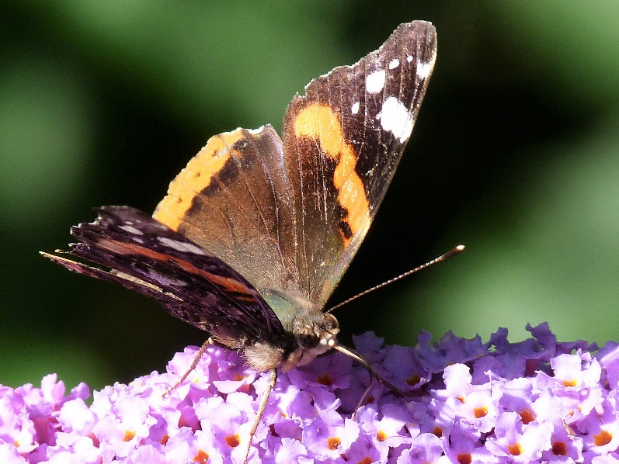

Red admiral

# Pesticide and Herbicide Use

Nationally it is recognised that the use of pesticides and herbicides should be reduced. As a Council we will strive to reduce use of pesticides and continue to test and trial other alternatives and where feasibly possible instigate alternative measures using up to date guidance from the Government, European Assessment Group on Glyphosates (AGG) and Suppliers

The best way of reducing pesticide use is to change our management practices and leave areas ‘wild’ to benefit wildlife. Not spraying areas and allowing weeds to grow will allow biodiversity gain but will need to be clearly explained to residents.

# Community Involvement

There are many ways that residents can become involved with enhancing the biodiversity of the Borough. We will continue to provide volunteering opportunities via our network of ‘Friends of’ Groups across the Borough. We will continue to engage with Forest Schools, Eco Councils and uniformed groups to provide support and opportunities for them to become involved in conservation projects in our parks or on their own land.

# An Action Plan for South Ribble’s Biodiversity

Over the course of the next year the Council will consult with staff and partners to put together a detailed Biodiversity Action Plan to sit with this Strategy. This will include;

* Conducting desk based and field surveys to gather baseline data for biodiversity (species and habitats) in South Ribble
* Linking with Lancashire Local Nature Partnership and other relevant local and national bodies
* Informing and educating staff, landowners and residents about Invasive Non-Native Species
* Continuing with and introducing new biodiversity friendly management practices on SRBC land
* Developing the Council’s response to Biodiversity Net Gain in the planning process
* Developing a communication plan for biodiversity including an element of Citizen Science to enable residents to be involved
* Ensuring where site management plans exist for our sites that they have an up to date section on biodiversity.
* Identifying sites that would benefit from the development of new management plans
* Continuing to support Friends of Groups across our parks and open spaces
* Continuing to improve habitats for our pollinating species

# References

Natural Environment and Rural Communities Act 2006 <https://www.legislation.gov.uk/ukpga/2006/16/section/40/2011-04-22?timeline=true> [online] accessed December 2021

Environment Act 2021 <https://www.legislation.gov.uk/ukpga/2021/30/part/6/enacted> [online] accessed December 2021

The Conservation of Habitats and Species Regulations 2017 <https://www.legislation.gov.uk/uksi/2017/1012/contents/made> [online] accessed December 2021

DEFRA (2021) Local Nature Recovery Strategies - how to prepare and what to include <https://consult.defra.gov.uk/land-use/local-nature-recovery-strategies/> [online] accessed December 2021

DEFRA (2021) Changes to the Habitat Regulations Policy Paper <https://www.gov.uk/government/publications/changes-to-the-habitats-regulations-2017/changes-to-the-habitats-regulations-2017> [online] accessed December 2021

South Ribble Local Plan 2015 <https://www.southribble.gov.uk/media/125/The-Adopted-Local-Plan-July-2015/pdf/Local_Plan_-_Adopted_July_2015_0.pdf?m=637369819342800000> [online] accessed January 2022

Central Lancashire Adopted Core Strategy Local Development Framework <https://www.southribble.gov.uk/media/138/Central-Lancashire-Core-Strategy/pdf/CentralLancashireCoreStrategy2012.pdf?m=637369838249630000> [online] accessed January 2022

Central Lancashire Biodiversity and Nature Conservation Supplementary Planning Document 2015 <https://www.southribble.gov.uk/media/120/Biodiversity-and-Nature-Conservation-/pdf/Final_Biodiversity_and_Nature_Conservation_SPD_-_July_2015.pdf?m=637369819327770000> [online] accessed January 2022

National Planning Policy Framework Guidance 2021 <https://www.gov.uk/government/collections/planning-practice-guidance> [online] accessed December 2021

South Ribble Borough Council Air Quality Action Plan 2018 <https://www.southribble.gov.uk/media/422/Air-Quality-Action-Plan/pdf/Air_Quality_Action_Plan_2018.pdf?m=637425364922300000> [online] accessed December 2021

South Ribble Borough Council Climate Emergency Strategy 2021 <https://www.southribble.gov.uk/article/1556/Contents> [online] accessed December 2021

JNCC (2019) UK Biodiversity Action Plan <https://jncc.gov.uk/our-work/uk-bap/> [online] accessed December 2021

Englands Biodiversity Indicators 2021 <https://assets.publishing.service.gov.uk/government/uploads/system/uploads/attachment_data/file/1025357/20_TB_Invasive_spp.pdf> [online] accessed December 2021

# Glossary of Terms

**Aquatic invertebrates** – animals without a backbone (e.g. insects) that spend the majority of their lifecycle in freshwater, marine of estuarine environments

**Aquatic vegetation** – a plant that grows partly or wholly in water

**Arisings** – grass cuttings left after mowing

**Biodiversity** – the variety of plant and animal life across the world

**Biodiversity net gain** – an approach to development that leaves biodiversity in a better condition than before

**Biosecurity** – measures aimed at preventing the introduction or spread of harmful organisms

**Deadwood** – parts of a tree or branch that are dead

**Differential mowing** – cutting grass to different heights and at different times

**Ecosystems** – a community of interacting organisms and their physical environment

**Invasive non-native species** – those species that have been introduced to a country by humans, whether accidentally or on purpose.

**Local distinctiveness** – the unique character of a place

**Marginal vegetation** – aquatic plants found around the edges of a pond or stream

**Perennial** – living for several years

**Principle Importance** – those species and habitats that are most threatened, in steepest decline or where the UK has a significant proportion of the world total.

**Priority habitats and species** – a range of habitats and species that were identified as the most threatened and requiring conservation action

**Riparian** – the edge of a river, or relating to this area

**River catchment area** – the area from which water flows into or is drained by a river

**Saproxylic species** – those species that are dependent on dead or dying wood

**Sward height** – the height of the grass before it is cut

**Symbiotic relationship** – a close ecological relationship between two or more different species